School of Informatics & Cybersecurity - Assessment Submission Coversheet

Student Information
Student Number: | B00162757
Student Name: | Cathal Farrell

Module Information
Module Title: | Web Framework Development
Module Code: | COMP H3037

Assessment Information
Assessment Title: | Project

Declaration
☑ I confirm that I have read and understood the University’s Academic Integrity Policy.
https://www.tudublin.ie/explore/about-the-university/academic-affairs/academic-quality-assurance-and-enhancement/academic-integrity/
☑ I have completed the TU Dublin AI Driving License theory test.
https://www.tudublin.ie/explore/about-the-university/academic-affairs/lta/lta-resources/artificial-intelligence-driving-license/
☑ I declare that this assessment submission is my own work.
☑ I confirm that I have read and understood the AI traffic light system used as part of this assessment brief and I have adhered to the level of AI usage allowed for this assessment.
Student Signature: Cathal Farrell
Date: 27/04/2026

Web Framework Development Project:
Retail – Training

Submitted by: Cathal Farrell, B00162757

Table of Contents . . .

Business Understanding
An e-commerce site that allows consumers to order items to be collected at a local shop and view orders that have not yet been collected.
The website will also provide training for employees as they are preparing to take on new roles within the company.

Business Requirements
- User’s can order new items to be delivered to their store of choice.
- User’s can check the details of orders that have not been collected.
- Employees’ roles can be managed quickly and easily.
- Employees receive a tutorial and are expected to pass a test upon receiving a new role. Unpassed tests are removed from employees notifications upon losing a role.

Use Cases
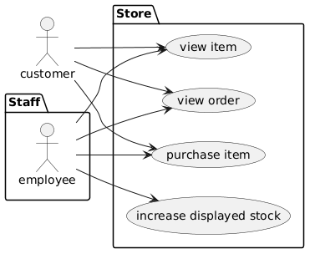
Any user can…
- View selection of items for sale.
- Purchase a product that is for sale.
- View an order they have previously made.
Staff can also increase the databases stock count for each product.

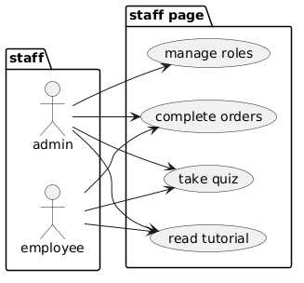
All staff users can…
- Complete outstanding orders.
- Read tutorials after receiving a new job position
- Take quizzes on said tutorials.
Admin users can also manage the roles of all users.

Database Design
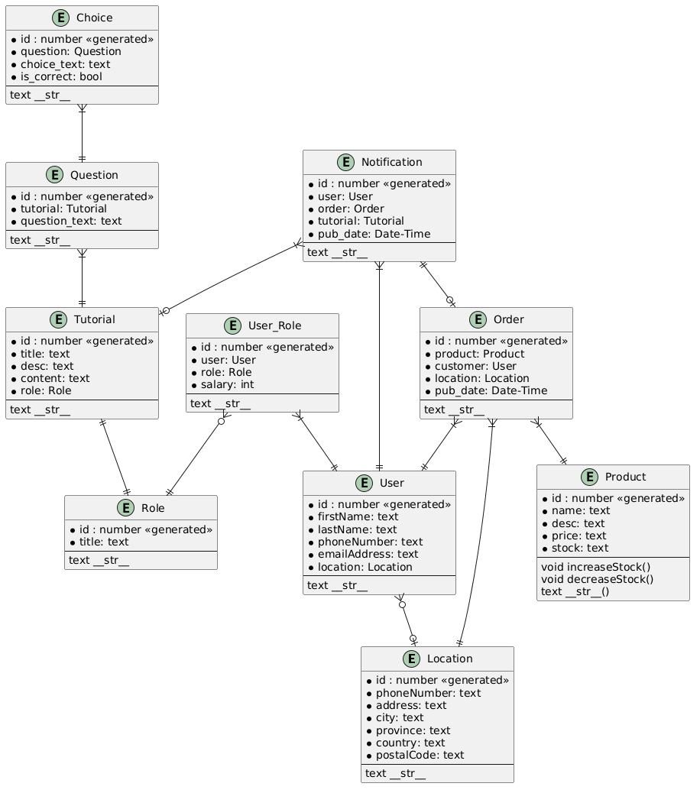

Django Framework Implementation
Model:
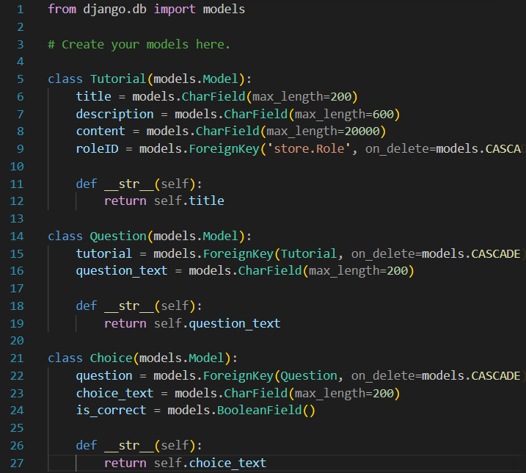
Figure 1: code from staff:model.py

Implementation
Each model was used as described in the ERD with minor changes to names of attributes, such as adding ID to the end of foreign keys’ names.

Relations
Tutorial -> Role:
1 to 1, each job position has a dedicated tutorial and quiz.
Tutorial -> Question:
1 to many, each tutorial has a set of questions that are asked in a quiz after reading.
Question -> Choice:
to many, each question has a few choices to select from when answering.
Location -> User:
1 to many, many employees can share a store location in which they are employed.
User_Role -> User:
1 to many, each role can be occupied by multiple people.
User_Role -> Role:
1 to many, each employee can hold multiple job positions.
Order -> Location:
1 to many, many orders can be delivered to the same store.
Order -> User:
1 to many, many orders can be ordered by the same customer.
Order -> Product:
1 to many, many order can be made for the same product.

View
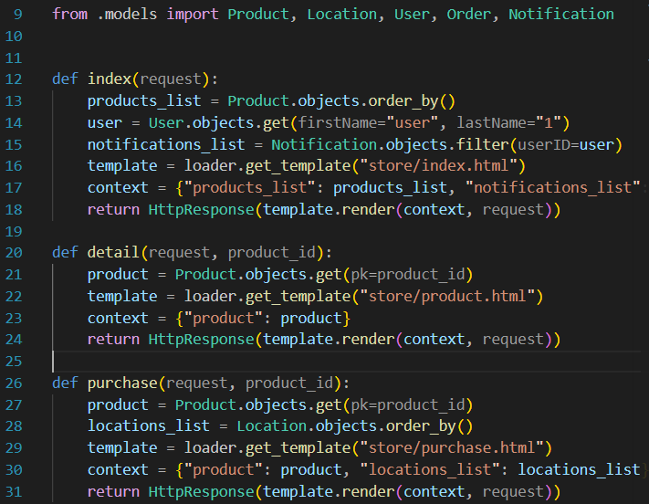
Figure 2: code snippet of display pages from store:views.py
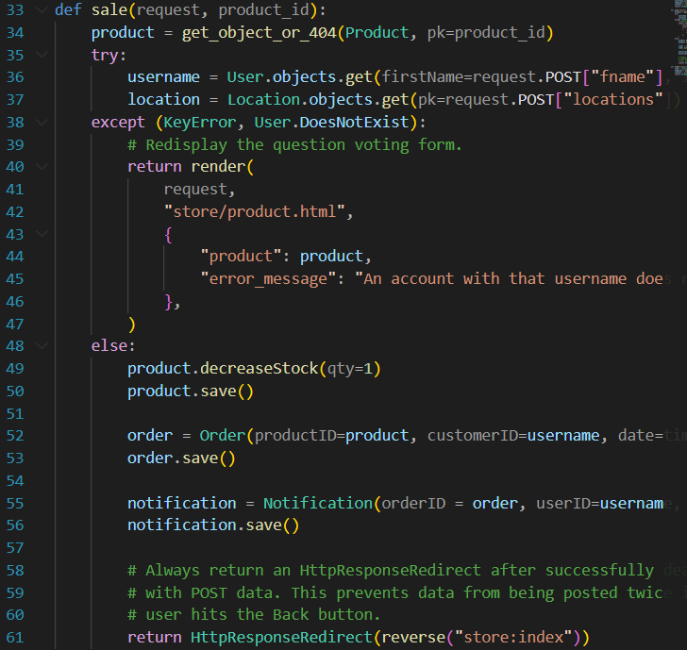
Figure 3: code snippet of function page from store:views.py
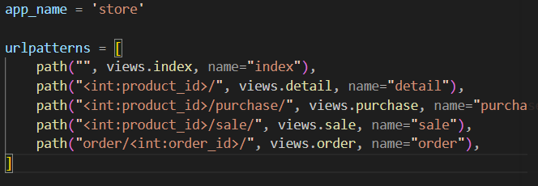
Figure 4: code snippet from store:urls.py

Template
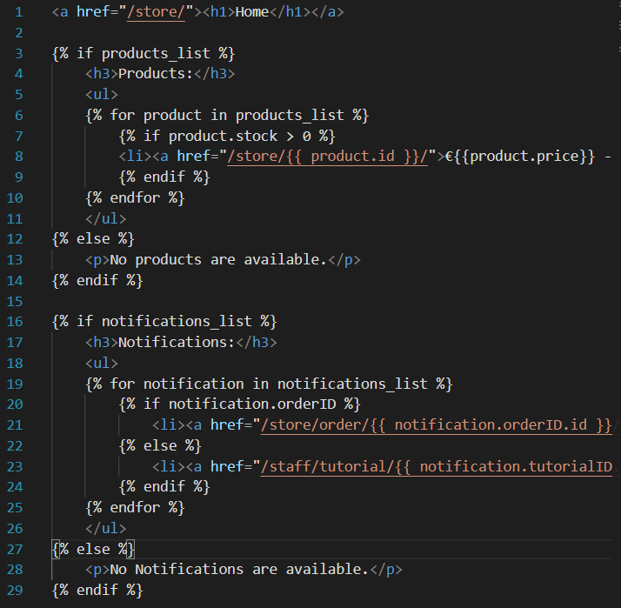
Figure 5: code snippet of store's index page from store:index.py

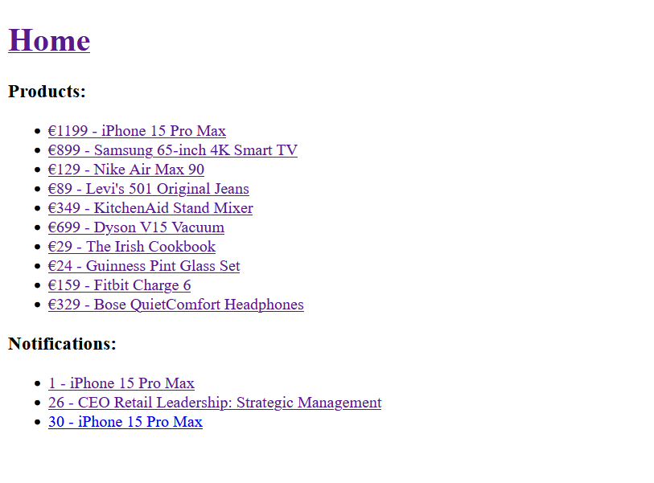
Figure 6: store's index page on live server

Project Testing
None.

Media Sources
None.

